Stratego

DESIGN DOCUMENT

By Jack Nealon

Introduction 3

Game Summary Pitch 3

Inspiration 3

Player Experience 4

Platform 4

Development Software 5

Genre 5

Concept 5

Gameplay overview 5

Theme Interpretation (Sacrifice Is Strength) 6

Rules of Movement 6

Secondary Mechanics 7

Art 8

Theme Interpretation 8

Design 8

Audio 9

Music 9

Sound Effects 9

Game Experience 10

UI 10

Controls 10

Development Timeline 10

## 

## Introduction

### Game Summary Pitch

Stratego is a strategy board game for two players on a board of 10×10 squares. Each player controls 40 pieces representing individual officer and soldier ranks in an army. The pieces have Napoleonic insignia. The objective of the game is to either find and capture the opponent's Flag or to capture so many enemy pieces that the opponent cannot make any further moves. Stratego has simple enough rules for young children to play but a depth of strategy that is also appealing to adults.

### Inspiration

The game is a slightly modified copy of an early 20th century French game named L'Attaque ("The Attack"), and has been in production in Europe since World War II and the United States since 1961. There are now two- and four-player versions, versions with 10, 30 or 40 pieces per player, and boards with smaller sizes (number of spaces). There are also variant pieces and different rulesets.

### Player Experience

**Strategic Depth**

Players carefully plan moves, balancing immediate tactics with long-term goals. The immovable lakes create choke points, requiring creative positioning and maneuvering.

**Psychological Warfare**

Hidden setups allow for bluffing and deception. Players must guess their opponent’s strategy while concealing their own, making every move a mind game.

**High Stakes**

Every decision carries weight. Misjudging an opponent's piece can lead to disaster, but smart plays can capture the Flag or cripple the enemy.

**Adaptive Gameplay**

With many possible moves and positions, players must quickly adjust their strategy as the game evolves, shifting between offense and defense as needed.

**Tactical Combat**

Combat is tense and decisive. When attacking, both players reveal ranks, with the weaker piece removed. Special pieces like the Bomb and Spy add unique tactical layers.

### Platform

The game is developed to be released on windows PC

### Development Software

* Java Programming language
* Java Swing for Graphics and UI

### Genre

Co-op, Two-player, puzzle, strategy

## Concept

### Gameplay overview

Players alternate moving; red moves first. The right to move first does not significantly affect game play (unlike chess). Each player moves one piece per turn. In the original rules, a player may move or strike, but not both. A player must move a piece in their turn; there is no "pass."

Two zones in the middle of the board, each 2×2, cannot be entered by either player's pieces at any time. They are shown as lakes on the battlefield and serve as choke points to make frontal assaults less direct.

The game can be won by capturing the opponent's Flag or all of their moveable pieces. It is possible to have ranked pieces that are not moveable because they are trapped behind bombs. In unusual cases, it is possible to draw, for example, when both players' flags are protected by bombs and each player has one remaining piece which is not a miner.

Unlike chess, Stratego is a game of imperfect information. In addition to calculated sequences of moves, this gives rise to aspects of battle psychology such as concealment, bluffing, lying in wait and guessing.

### Setup

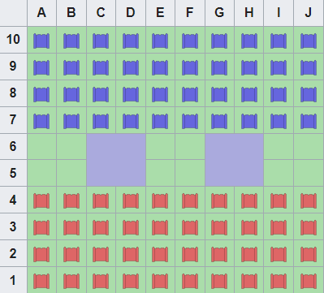Typically, color is chosen by lot: one player uses red pieces, and the other uses blue pieces. Before the start of the game, players arrange their 40 pieces in a 4×10 configuration at either end of the board. The ranks are printed on one side only and placed so that the players cannot identify the opponent's pieces. Players may not place pieces in the lakes or the 12 squares in the center of the board. Such pre-play distinguishes the fundamental strategy of particular players and influences the outcome of the game.

### Rules of Movement

1. All movable pieces, except the Scout, may move only one step vertically or horizontally (not diagonally).
2. A piece may not move onto a space occupied by a like-color piece.
3. Bomb and Flag pieces are immovable.
4. The Scout can move any number of spaces in a straight line, similar to a rook in chess.
   1. In older versions, the Scout could not move and strike in the same turn.
   2. In newer versions, the Scout can move and strike in the same turn.
5. No piece can move back and forth between the same two spaces for more than three consecutive turns (two-square rule).
6. To attack, a player strikes by moving their piece onto a square occupied by an opposing piece.
   1. Both players reveal their piece's rank; the weaker piece is removed.
   2. If the engaging pieces are of equal rank, both are removed.
7. A piece may not move onto a square already occupied unless it attacks.
8. Following a strike, the winning piece occupies the space vacated by the losing piece.
9. Bombs have special attack powers:
   1. They eliminate any piece that strikes them, except for Miners, who can defuse them.
10. The Spy has special attack powers:
    1. It can only defeat the Marshal if it attacks first.
    2. If the Spy attacks any other piece or is attacked by any piece (including the Marshal), the Spy is defeated.

## Art

### Theme Interpretation

For the digital version of Stratego, we'll keep the classic battlefield theme but use more vibrant colors. Red and blue will represent the two sides, with a neutral board color to keep the focus on the game. We’ll add some light textures and gradients to make the game look modern without taking away from the strategy.

### Design

The design will be simple and clear. Each piece will be easy to recognize with bold colors and simple icons, so players can quickly understand the game. The board and pieces will have a clean look, using strong contrasts to make everything easy to see and use. This approach will keep the game smooth and enjoyable to play.

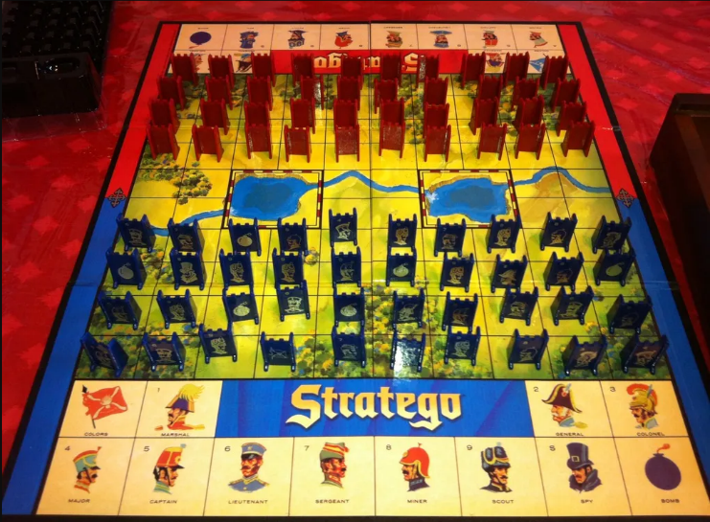

## Audio

### Music

No such plans at this time, however some classical commanding background music could be added at some point.

### Sound Effects

No plans at this time but possible sound effects could be added including moving pieces, defeating an opponent’s piece(win), losing a piece (loss), start the game, end the game, etc.

## Game Experience

### User Interface

The UI will be developed with a focus on simplicity while incorporating additional features as the project evolves. I plan to integrate superimposed images and explore 3D modeling to enhance the visual experience but it may come secondary. The game pieces will be interactive, allowing players to pick them up and move them seamlessly, similar to standard board game software or mobile apps. For the initial phase, Java Swing will be utilized to build the interface, providing a solid foundation for further enhancements.

### Controls

**Mouse and Keyboard**

Click and Drag

## Development Timeline V1.0

Refer to Github Projects for Updated List

| **#** | **Assignment** | **Type** | **Status** | **Finish By** | **Notes** |
| --- | --- | --- | --- | --- | --- |
| 1 | Game Design Document | Other | In progress | Sep 4, 2024 |  |
|  | UML Diagram Complete | Art | In progress | Sept 4,  2024 |  |
|  | Complete initial board and piece visuals | Coding | In progress | Sept 4,  2024 | Visual board and pieces with limited functionality |
|  | Initial Working Prototype | Coding | Not started | Sept 6, 2024 | Base movements and game rules |
|  |  | Coding | Not started |  |  |
|  |  | Coding | Finished |  |  |
|  |  | Coding | Finished |  |  |
|  |  | Coding | Finished |  |  |
|  |  | Coding | Finished |  |  |
|  |  | Art | Finished |  |  |
|  |  | Art | Finished |  |  |
|  |  | Audio | Finished |  |  |
|  |  | Coding | Finished |  |  |
|  |  | Coding | Finished |  |  |
|  |  | Other | Finished |  |  |
|  |  | Other | Finished |  |  |
|  |  | Other | Finished |  |  |
|  | Completely Finished, Deploy and Release V1.0 | Coding | Finished | Sept 30, 2024 |  |

**BEYOND (if ahead of schedule / extra time)**

|  |  |  |  |
| --- | --- | --- | --- |
| Undo | Other | Not started | At any point, the player may undo their move, any movement, creation, or destruction of a player cell is reversed |
| Extra levels | Other | Not started |  |
| Settings Menu | Coding | Finished | Volume slider, fullscreen toggle |